CREATINGINSTANCEFORWINDOWS

Roll no: 23A85A6108

Name: Rama Krishna

Branch: AIM-A

Step1:launchtheinstanceintheEC2tab.

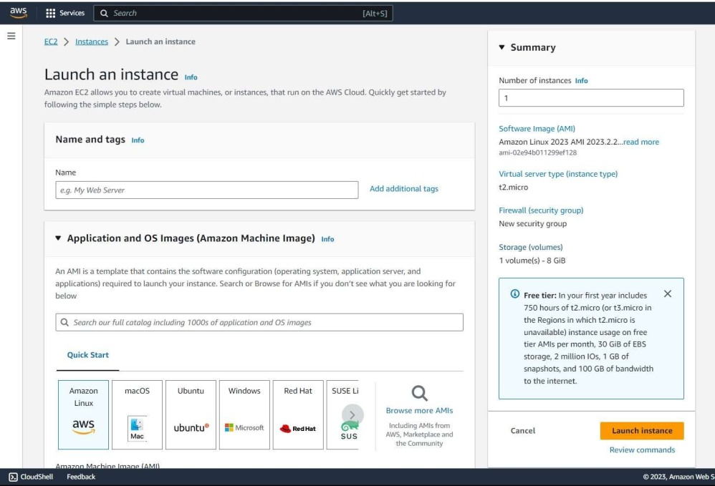

Step2:

SelecttheAMIoffree-tier andthe instancetype :

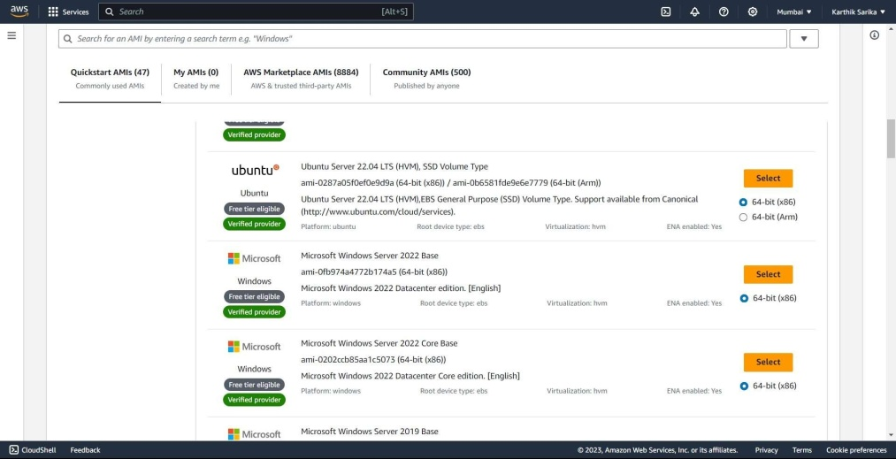

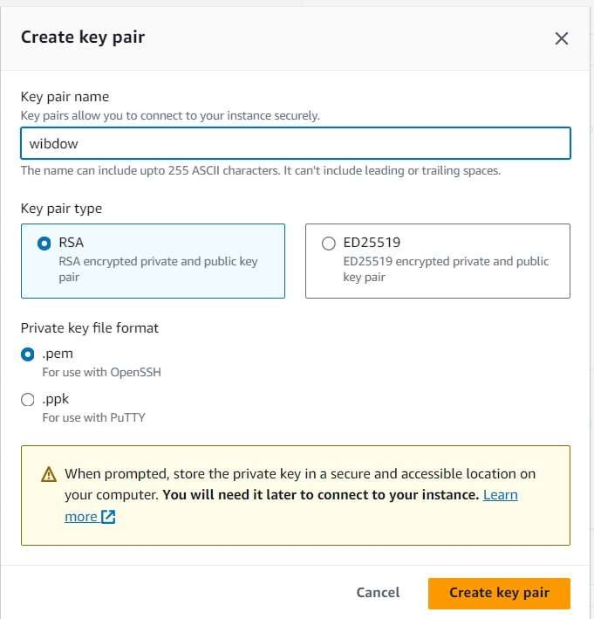Step3:Createakey-pairofyourinterest.

Step4: ConnecttoRDC.

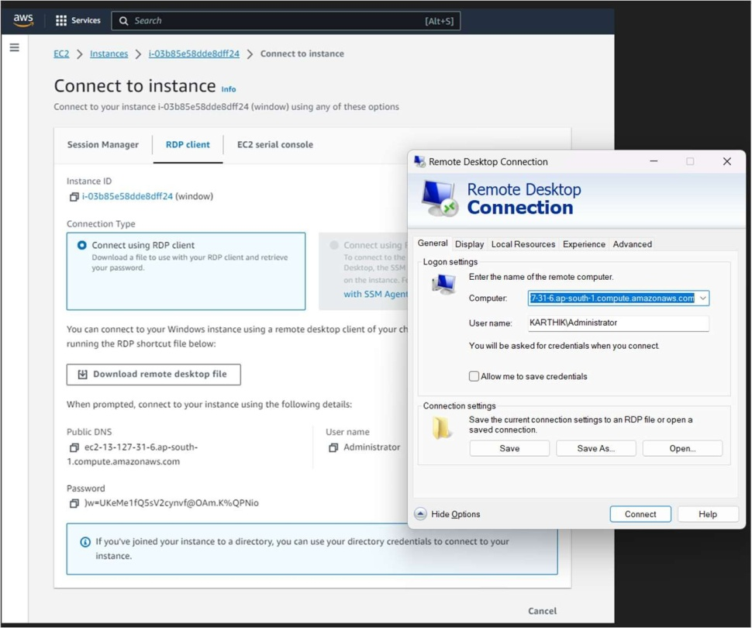

Step5:windowsinstancewillbelaunchedwith30gb storage



